121 Limestone Crescent
Toronto, ON M3J2R1
Phone: 416-900-6036
Fax: 1-888-351-4685
Email: info@expresscollection.ca
Website: expresscollection.ca

Pre-Authorized Debit Form

To: Canadian Express Collection Agency (the "Payee")
This Authorization is provided for the benefit of the Payee and our Financial Institution and is provided in consideration of our Financial Institution agreeing to process debits against our account in accordance with the Rules of the Canadian Payments Association (the "CPA Rules").

INSTRUCTIONS: Please complete all sections to instruct your Financial Institution to make payments directly from your account. Mail, Fax or Email the completed form with a blank cheque marked "VOID" to above address or number.

Account Holder

Account Holder’s Name: Phone:

Home Address:

City: Province: Postal Code:

Financial institution information:

Bank Name:

Transit #:

Financial Institution #:

Account #:

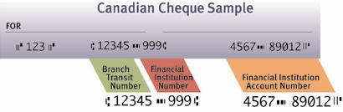

Credit Card Payments:

Master Card Visa American Express

Name (as it appears on the credit card):

Credit Card Number: Expiry Date:

Billing Address:

City: Province: Postal Code:

Frequency and Amount of Debits: A debit, in paper, electronic or other form in the

amount of $____________ will be drawn on our account

Weekly
Monthly
Bi-monthly

Or on the following dates:
_______
_______
_______
_______

beginning _______________ .

Authority To Debit Account: We hereby authorize Canadian Express Collection Agency to draw on our account indicated above with our Financial Institution, for the purpose of satisfying our collection account.

_________________________________________________
Authorized Signatory Name (please print) Date

